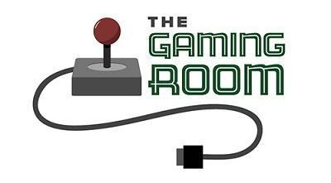

Draw It or Lose It

CS 230 Project Software Design Template
Version 1.0

Table of Contents

CS 230 Project Software Design Template 1
Table of Contents 2
Document Revision History 2
Executive Summary 3
Requirements 3
Design Constraints 3
System Architecture View 3
Domain Model 3
Evaluation 4
Recommendations 5

Document Revision History

Version | Date | Author | Comments
1.0 | 06/01/26 | Naeem Sutton | Completed CS 230 software design document.

Instructions
Fill in all bracketed information on page one (the cover page), in the Document Revision History table, and below each header. Under each header, remove the bracketed prompt and write your own paragraph response covering the indicated information.

Executive Summary

The Gaming Room intends to extend "Draw it or lose it" (the current android application) in order to create a web-based version of the application. Players will then be able to play on different types of devices and/or operating systems. For the new version of the application, they intend to develop it with java and object-oriented programming to make it easy to organize, efficient, and for maintenance purposes. They will include features that enable many players/team members to participate within the same game while ensuring each player's name remains unique throughout the entire application. Designing the application with design patterns such as the Singleton Pattern and Iterator Pattern will also provide the opportunity to increase performance, decrease duplicated data, and assist in scalability when there are additional users.

Requirements

The program will need to be able to support a minimum of one or more teams for participation in games, where at least two players are on each of the participating teams. All names (game name, team name, player name) must be uniquely identifiable so that users do not mistakenly enter duplicate names. Because this has evolved from an internal desktop based application into an internet based product, it needs to run across a number of different platforms including but not limited to windows, linux, mac osx, and mobile. Additionally, because it is now written as a "web" application; it needs to use good object oriented design techniques to make it easier to read, maintain and modify over time.

Design Constraints

One main constraint for the application's architecture design is that it has to run correctly on various different operating systems and devices without creating a new version of the software for each. Also, because the system has to handle many users (at one time), the system has to be able to create a unique ID and keep track of user name duplication. The other constraints are keeping the servers working well; protecting the user's information; managing all of the networking with in-game communications; and allowing the system to scale up as more players play the game. All these factors help determine how the software is going to have to be designed and therefore need serious planning before the actual build process begins.

System Architecture View

The app has been designed as a distributed system in which end-users can access the gaming environment using one or more of their own devices. While each user will be accessing the game via their device (client), the game's data (teams, players etc.), and all communications between clients/users is managed on the serverside.

Domain Model

The entity relationship diagram illustrates the primary classes that manage the organization of the application “Draw It or Lose It”. The “Entity” class is the base class as it will hold both an ID field and a name field as the “Game”, “Team”, and “Player” classes are child classes inheriting from the “Entity” class. Because they share these same common fields, the code does not have to be repeated in each of these classes; therefore making this design clean.
The “GameService” class controls the collection of games (in other words, manages) and assigns unique identifiers to games, teams, and players. In addition, the “GameService” class utilizes a singleton design pattern to ensure there is only one instance of “GameService” running at any time. A game can have many team(s), and each team can have many player(s). Therefore, this satisfies the client’s requirements as well as allows for a variety of possible combinations of games having multiple teams and teams having multiple players. Encapsulation is illustrated by the fact that each class maintains its own data, but instead offers methods to either retrieve or modify that data. As such, this overall design improves maintenance by reducing redundant code, and ensures that the names assigned to items throughout the system remain unique.

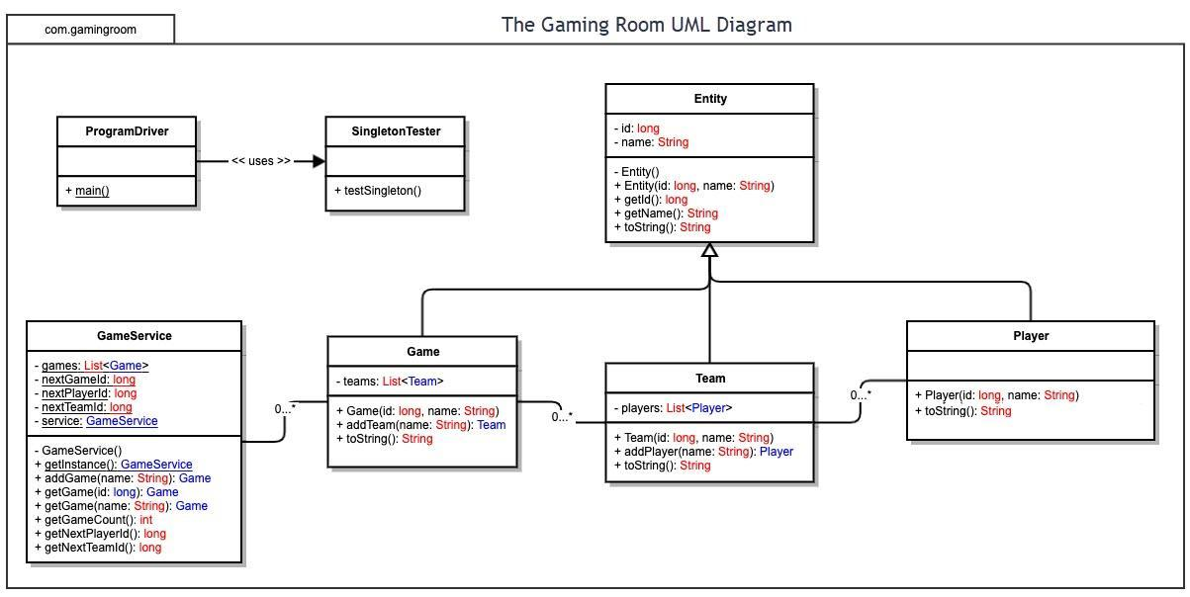

Evaluation

Using your experience to evaluate the characteristics, advantages, and weaknesses of each operating platform (Linux, Mac, and Windows) as well as mobile devices, consider the requirements outlined below and articulate your findings for each. As you complete the table, keep in mind your client’s requirements and look at the situation holistically, as it all has to work together.

In each cell, remove the bracketed prompt and write your own paragraph response covering the indicated information.

Development Requirements | Mac | Linux | Windows | Mobile Devices
Server Side | Mac can host web applications and is stable, but it is usually more expensive and less common for server hosting. | Linux is the best server option because it is secure, reliable, low cost, and commonly used for web applications. | Windows can host web applications and is easy to manage, but licensing costs and resource usage can be higher. | Mobile devices are not a good choice for server hosting because they have limited power, storage, and reliability.
Client Side | Mac users can access the game through a web browser, but testing is needed to make sure it works well on Safari and macOS. | Linux users can access the game through common browsers, but testing may take more time because Linux has many versions. | Windows is widely used, so the game should be tested carefully on browsers like Chrome, Edge, and Firefox. | Mobile users need a responsive design so the game works on smaller screens and touch controls.
Development Tools | Java, Eclipse, IntelliJ IDEA, Git, and browser testing tools can be used for Mac support. | Java, Eclipse, Git, Apache, MySQL, and Linux server tools can be used for development and hosting. | Java, Eclipse, Visual Studio Code, Git, and Windows testing tools can be used for development. | Android Studio, Xcode, Java, responsive web frameworks, and mobile browser testing tools can be used.

Recommendations

Analyze the characteristics of and techniques specific to various systems architectures and make a recommendation to The Gaming Room. Specifically, address the following:

- Operating Platform: Linux would be the best operating platform for Draw It or Lose It because it is reliable, secure, scalable, and commonly used for web-based applications. Linux also has lower operating costs compared to other server platforms and works well in distributed environments.

- Operating Systems Architectures: Linux supports distributed system architectures and cloud-based hosting, which makes it easier for the application to handle multiple users at the same time. It also supports virtualization and multi-threaded applications, which improves performance and scalability.

- Storage Management: A relational database system such as MySQL would work well for storing game, team, and player information. This allows data to stay organized while supporting fast searches and updates.

- Memory Management: Java provides automatic memory management through garbage collection. This helps reduce memory leaks and improves application stability while the game is running.

- Distributed Systems and Networks: The application can communicate across different platforms through web servers and network connections. Since the game is web-based, players can connect through browsers on different devices. Reliable internet connectivity and stable servers are important to prevent outages and maintain communication between users.

- Security: User information should be protected using encryption, secure logins, firewalls, and role-based access controls. Linux also provides strong built-in security features and regular updates to help protect the application and its users from security threats.

